**PDMS Substrate Ablation**

Miller Lab

Jacob Albritton

**Equipment/Materials**

**Procedure**

1. Turn on the laser water pump. (Very important!)

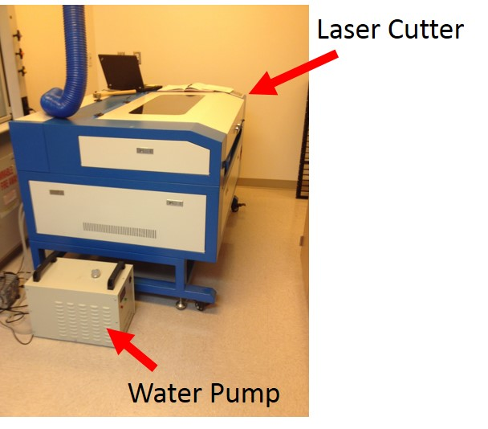 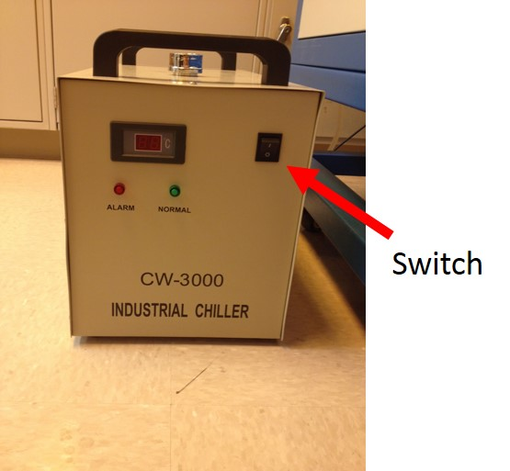

1. Verify that the laser water pump is running! The laser can overheat without cooling.

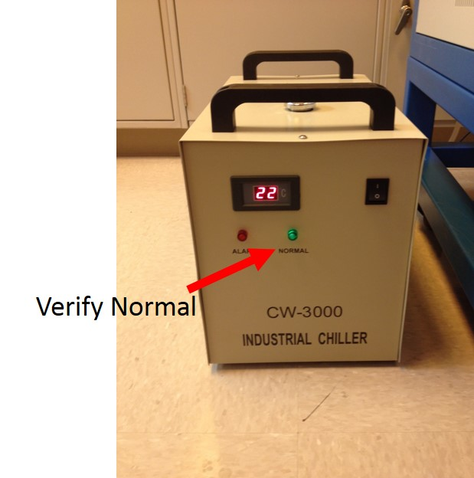

1. Verify that you verified that the laser water pump is on. (3 times)

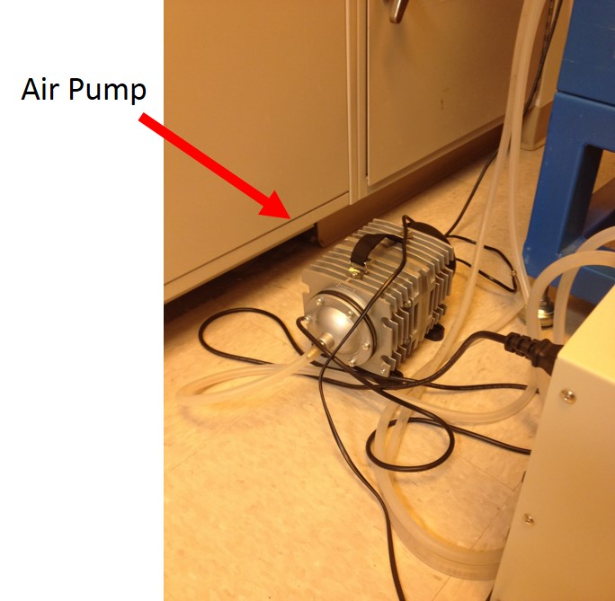

1. Turn on water pump, then the laser control unit (not the laser). To switch an emergency stop button on, twist the button clockwise about a quarter turn until the whole button releases outward. The RAMBo board will turn on with the laser control unit.

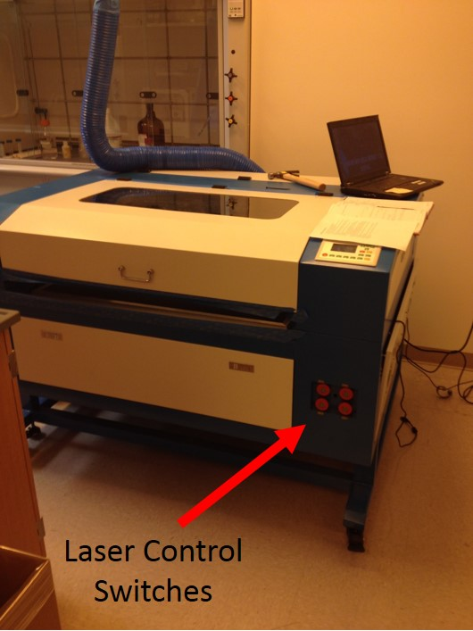 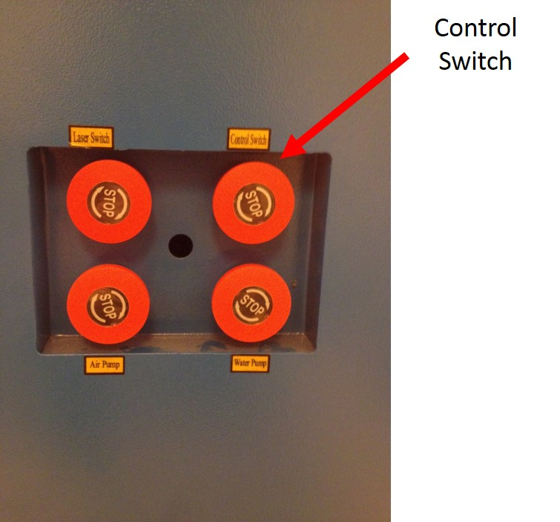

1. Plug the RAMBo USB cable to a Pronterface enabled computer.

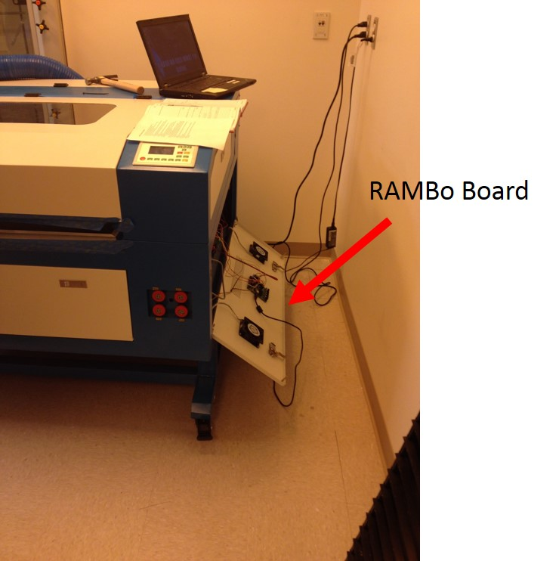 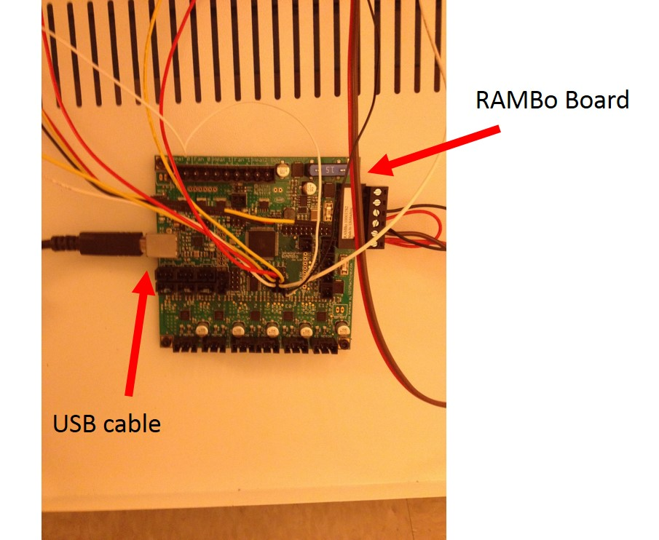 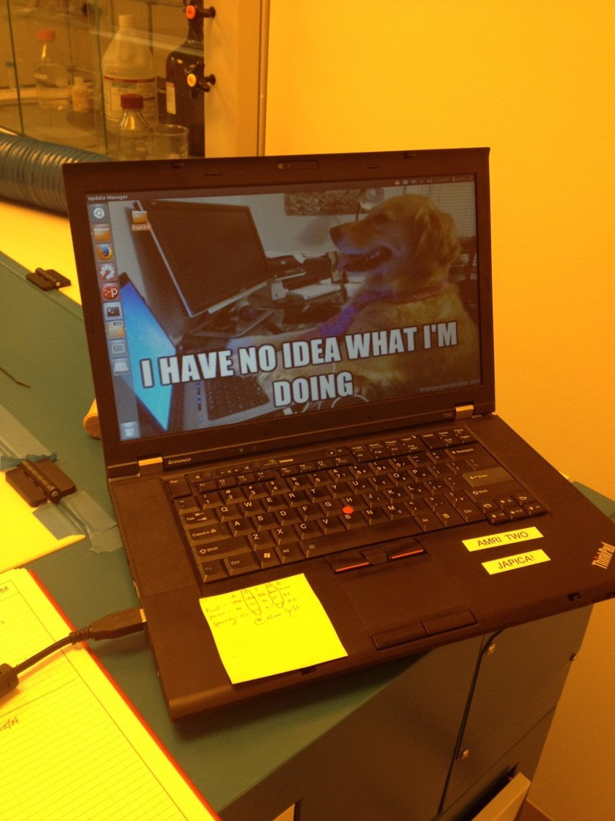

1. Start pronterface. After opening the terminal, navigate to the folder containing pronterface.py using the “cd” command. Use the “python” command with “pronterface.py” to open pronterface. Currently on the AMRI-Two lab computer, after opening the terminal, the following command should open pronterface:
   * python sls/Printrun/pronterface.py

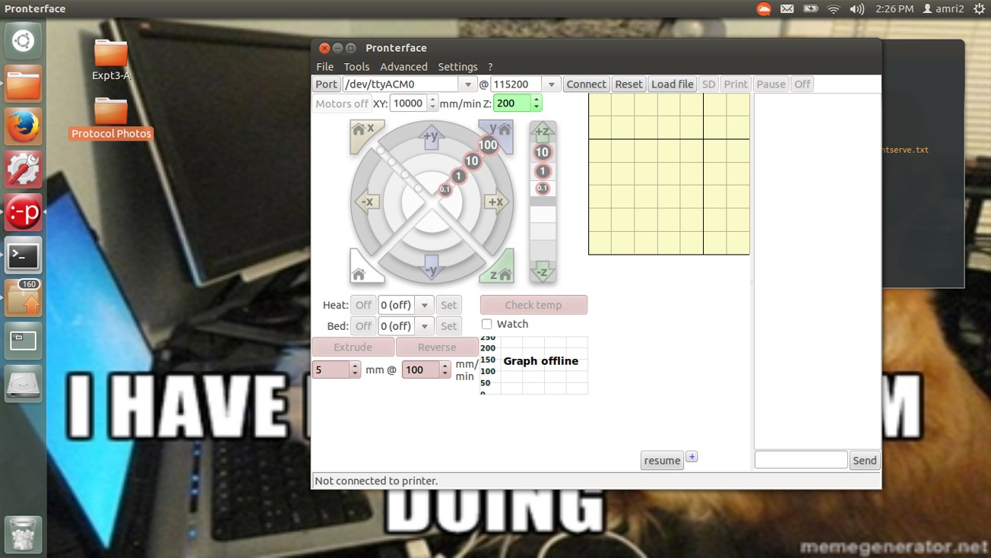

1. On pronterface, click on Connect to get the RAMBo board online. Make sure the Baudrate is set at 115200 (top dropdown box next to “@” symbol). You may also have to check different Com ports to get the right USB port.

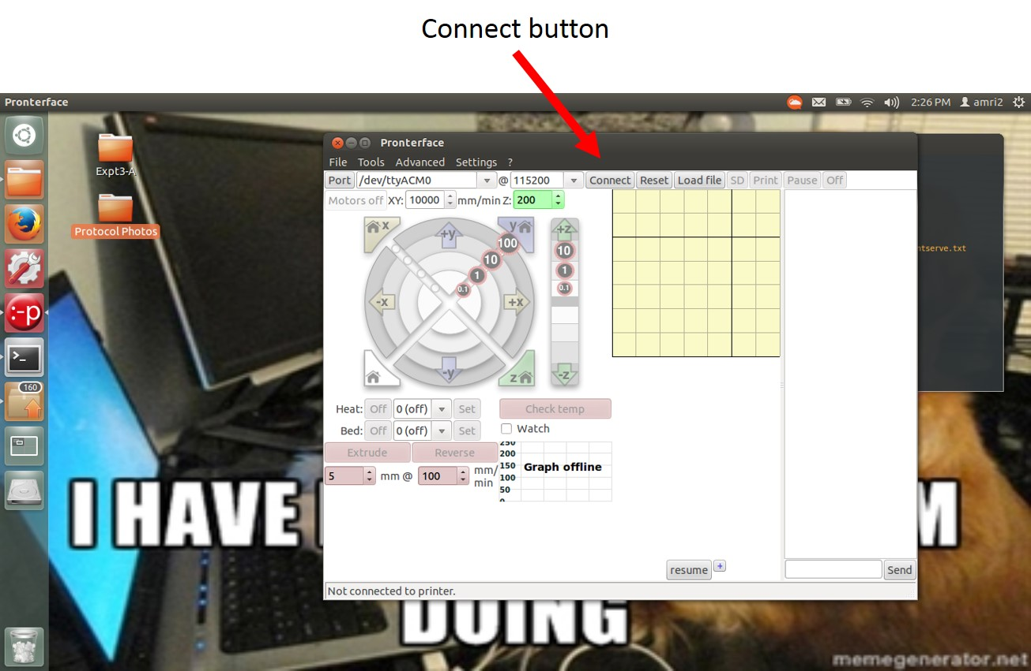

1. Test the connection by clicking on the home all button on Pronterface (bottom left button with house symbol). The laser head should move to the endstops in response.
2. Click on Load, and navigate to the .gcode file you have generated.
3. Manually move the laser head to the desired starting position using pronterface arrows labeled “+x”, “-x”, “+y”, and “-y”.

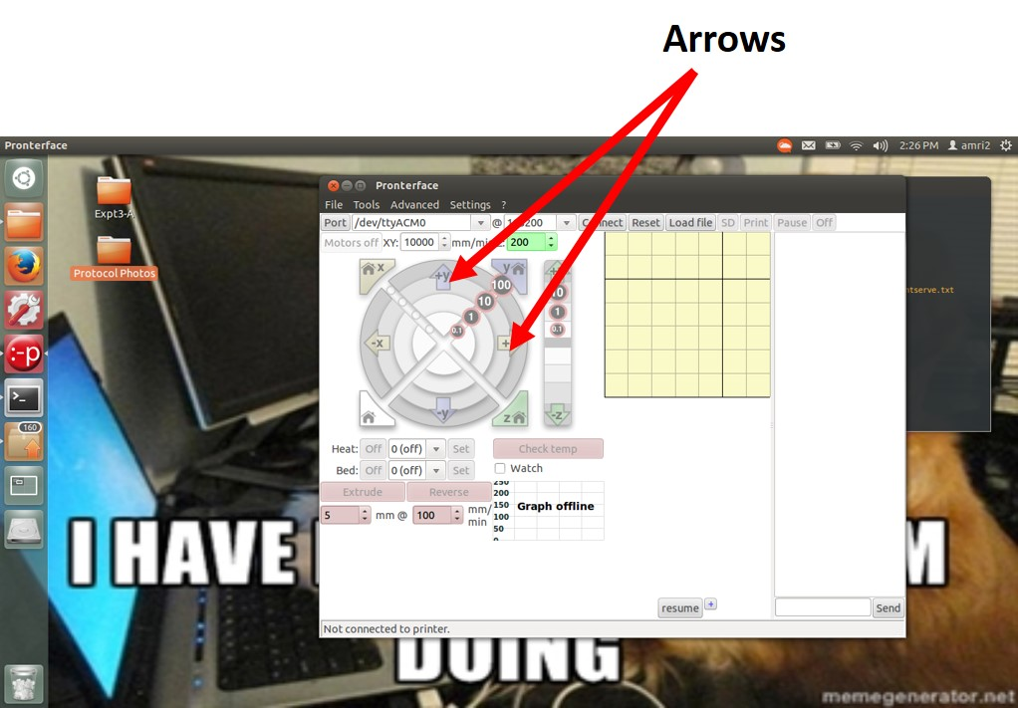

1. Turn on the laser.

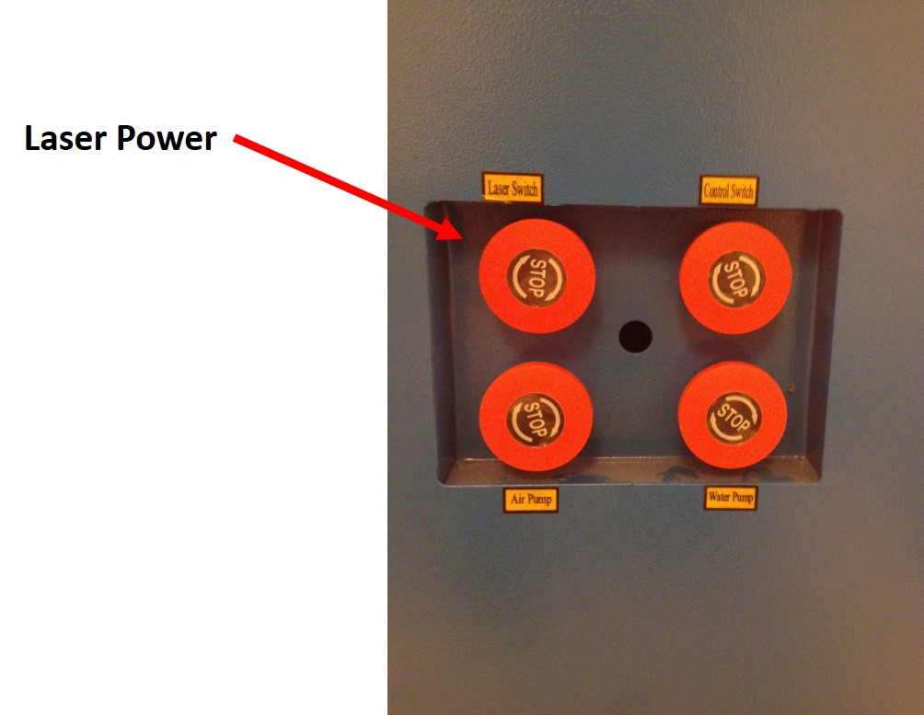

1. On pronterface, click print and wait until the laser starts ablating your sample.
2. Once the print is done turn off the machine in the following order
   * Laser Power
   * Laser Cutter Control
   * Air Pump/Water Pump
3. Turn water pump and unplug the air pump.